**Tableau**

**1. Basics:**

What is the difference between Discrete and Continuous Data?

**Ans:**

The key distinction between discrete and continuous data is that discrete data is countable data with specific values separated by spaces or intervals. Continuous data, on the other hand, is quantifiable data that conveys a continuous sequential pattern without interruptions indicating streamflow.

Discrete data is a sort of numerical data that comprises full, tangible numbers with particular and definite data values obtained by counting. Continuous data consists of complex numbers and fluctuating data values that are measured over a defined time span.

1. What are the criteria for data to land into dimensions and measures?

**Ans:** Dimensions include qualitative qualities (such as names, dates, or geographical data). Dimensions may be used to categorise, segment, and disclose features in your data. The level of detail in the view is affected by dimensions. Measures are numerical, quantitative quantities that may be measured.

1. What is Metadata, where is it present in the workbook?

**Ans:** Tableau records the source's metadata, such as the columns and data types. This is what is utilised to generate the dimensions, measurements, and computed fields that are used in views.

1. What happens when you aggregate or disaggregate the Data?

**Ans:**  Aggregate data is data that has been compiled and summarised; disaggregate data is data that has been aggregated and has been broken down into component pieces or smaller units of data.

1. You are working on a dataset, the client adds in more data to the dataset. What happens to the Visualization that you had created? Give the explanation for both Live and Extracted data.

**Ans.** If client adds more data, the visualization remains unchanged for extracted data until you refresh, whereas visualization gets updated for live data.

1. What are the file extensions in Tableau and how each one is different?

**Ans:** We can save our work using several different Tableau specific file types: workbooks, bookmarks, packaged data files, data extracts, and data connection files. Each of these file types are described below.

1. **Workbooks** (.twb) – Tableau workbook files have the .twb file extension. Workbooks hold one or more worksheets, plus zero or more dashboards and stories.
2. **Bookmarks** (.tbm) – Tableau bookmark files have the .tbm file extension. Bookmarks contain a single worksheet and are an easy way to quickly share your work.
3. **Packaged Workbooks** (.twbx) – Tableau packaged workbooks have the .twbx file extension. A packaged workbook is a single zip file that contains a workbook along with any supporting local file data and background images. This format is the best way to package your work for sharing with others who don’t have access to the original data.
4. **Extract** (.hyper or .tde) – Depending on the version the extract was created in, Tableau extract files can have either the .hyper or .tde file extension. Extract files are a local copy of a subset or entire data set that you can use to share data with others, when you need to work offline, and improve performance.
5. **Data Source** (.tds) – Tableau data source files have the .tds file extension. Data source files are shortcuts for quickly connecting to the original data that you use often. Data source files do not contain the actual data but rather the information necessary to connect to the actual data as well as any modifications you've made on top of the actual data such as changing default properties, creating calculated fields, adding groups, and so on.
6. **Packaged Data Source** (.tdsx) – Tableau packaged data source files have the .tdsx file extension. A packaged data source is a zip file that contains the data source file (.tds) described above as well as any local file data such as extract files (.hyper or .tde), text files, Excel files, Access files, and local cube files. Use this format to create a single file that you can then share with others who may not have access to the original data stored locally on your computer.

**2. Text Table, Highlight Tables, Heat Maps, Tree Map:**

1. Create a text table for the Avg (Sales) for each subcategory using Sample Superstore? List which Sub Category is got Avg (Sale) more than $1000? - **Sample Superstore**

**Ans:**

1. Create a Heat Table for the order date and Region against the Sub Category based in Count of Sales with two colours diverging that is distinguished by Sum of Profit - **Sample Superstore**

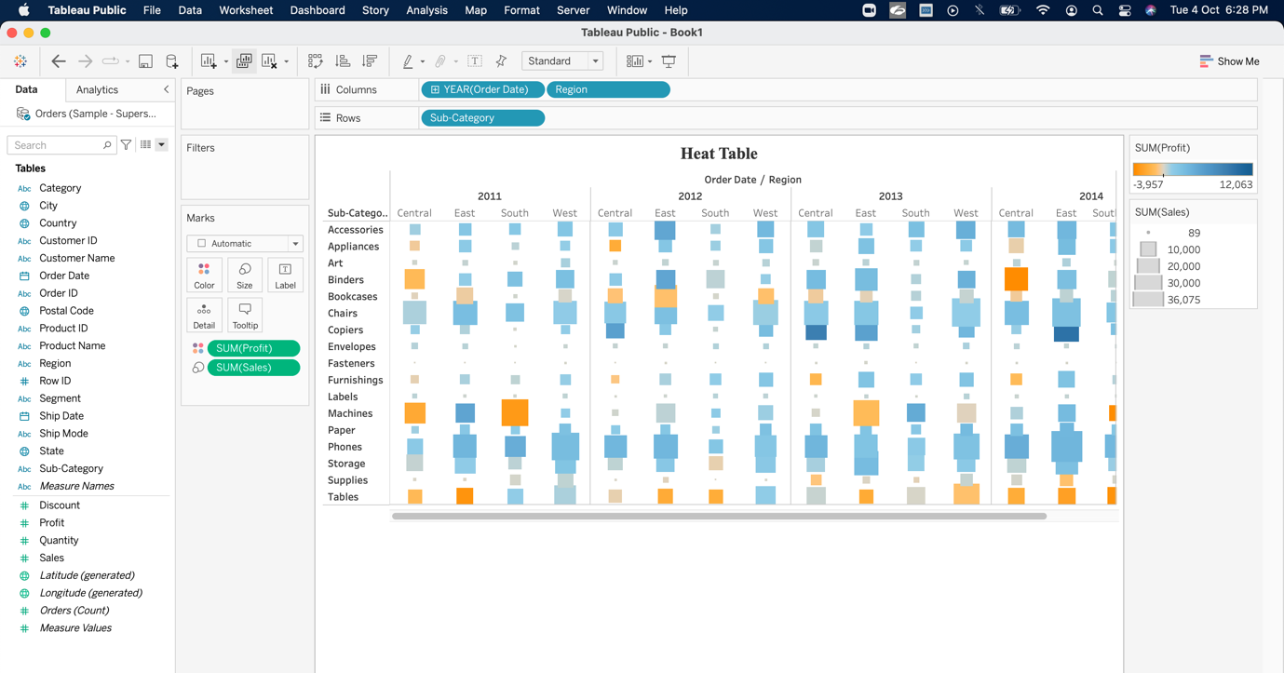**Ans:**

1. Create a Highlight table for the States for the Order Date Year whose highlighting is done based on Sum of profits - **Sample Superstore**

**Ans:**

1. Which customer is having maximum of sales in the year 2012? - **Global Superstore**

**

1. How much is profit share less in Pennsylvania when compared to New York? - **Sample Superstore**

**Ans:** 89,599

1. Check for the pane wise percentages of sales with Category, Sub- Category and quarter wise order date, also check for the Row wise grand totals and Column wise grand totals. - **Sample Superstore**

**Ans:** 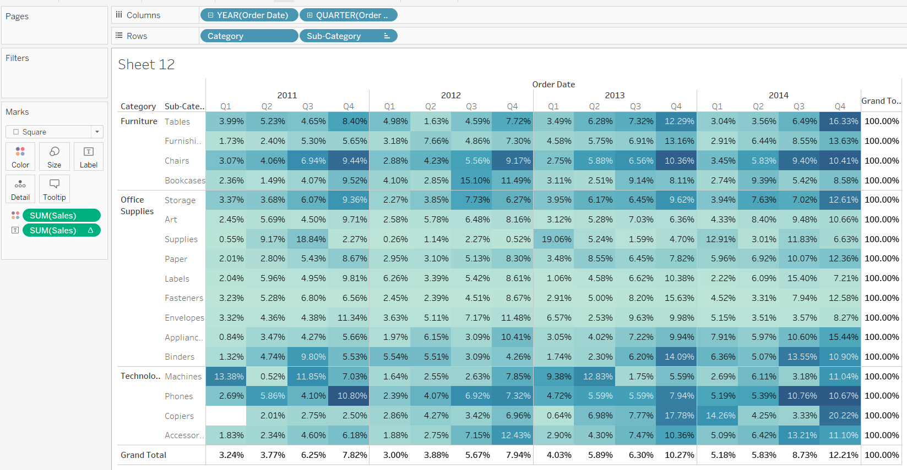

**3. Filled Maps, Symbol Maps:**

1. Use Global Superstore. Check Which Western Country in EMEA region has least profit percentage.

**

1. Use **“Sample Superstore. Xls”,** which state shares boarders only profit for tables

**

1. Use **“Sample Superstore. Xls”,** which state has no data for Profits for Office Supplies

**Ans:** Wyoming

**4. Bar Charts, Stacked, Side by Side:**

1. Graphical user interface, application

   Description automatically generatedWhich Customer name & Year is having all the Product Categories sum of profit less than over-all Average profit? - **Sample Superstore**

**Ans:**

1. What is the Maximum of Life Expectancy Female for the region Africa & year 2012? - **World Indicators**

**Ans:** 78(Africa)

1. What is the share of the top 20 customers based on the sales amount compared to the customers based on profit amounts - **Sample Superstore**

**Ans:**

**5. Line Graphs, Dual Line and dual axis:**

1. How can you show two different graphs in one view? - **Global Superstore**

**Ans**: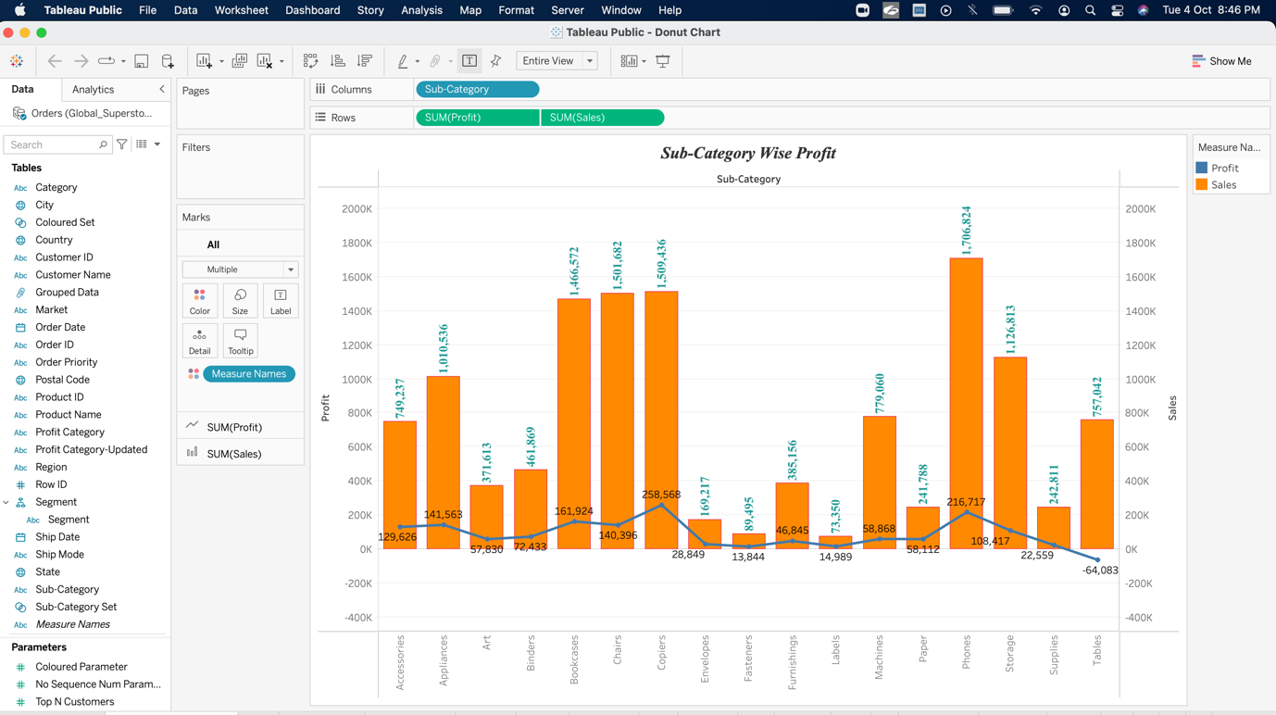

1. Which Region is having Sum of Energy Usage>1000000 and sum of Population 65+>10? - **World Indicators**

**Ans.** Asia, America, Europe, Africa.

**6. Trend lines, Cluster, scatter Plot, boxplot, Word Cloud (Packed Bubbles), Histogram:**

1. Draw a trend line for profit as a linear function of sales only for product technology? - **Sample Superstore**

**Ans.** 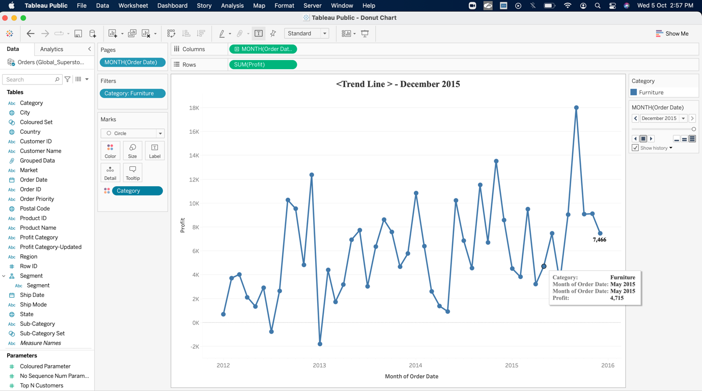

1. Create a histogram showing the number of Sales using Sales Bins of $1000. Which bins have profit ratios of more than 25%? - **Global Superstore**

**Ans**:

1. Using “**Sample Superstore”**, use order sheet create a histogram showing the number of orders using sales bins of $1000.

**Ans.**

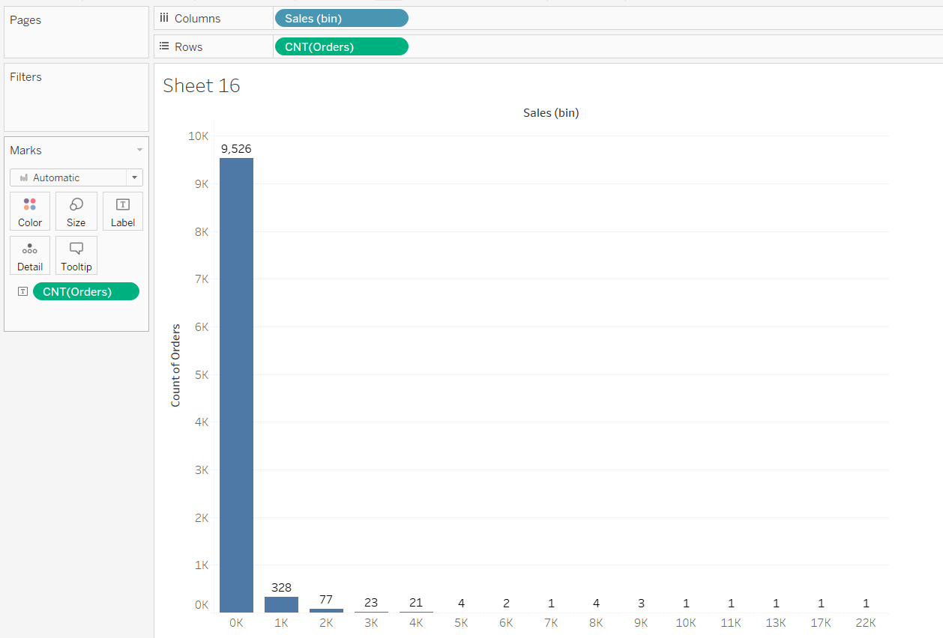

1. Using **“Global Superstore**”, use the orders sheet, build a scatter plot showing the sum of sales on the x-axis and sum of profits on the y axis for all products (Product name). What is the equation for linear regression for products in Technology?

**Ans.**

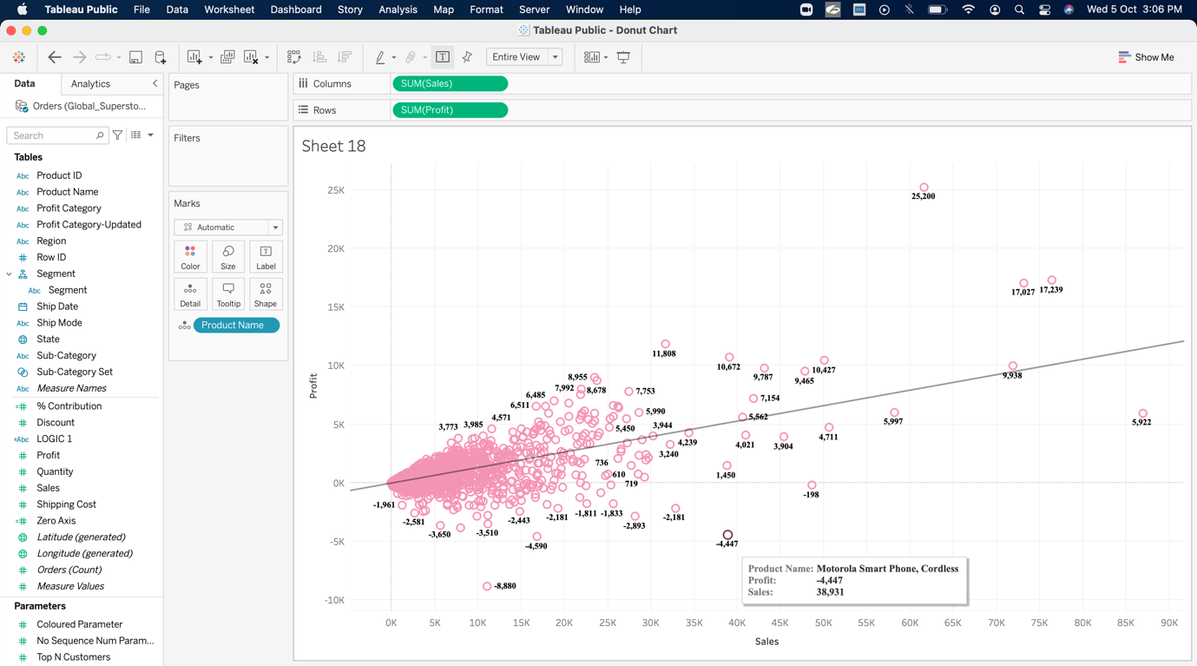

1. Use **“World Indicators”.**  Take Health Exp% GDP, Health Exp/Capita, Life Expectancy Male, Female. What are the variables that are considered to create the clusters by default?

**Ans.**

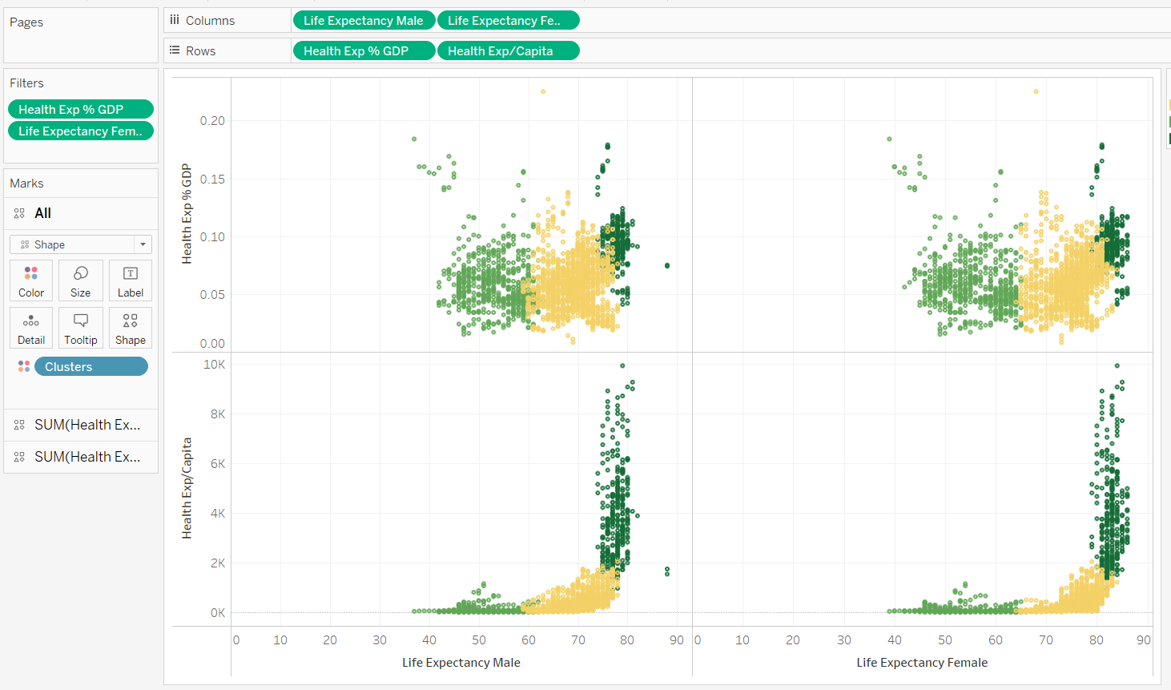

**7. Calculate Fields, Quick table calculations, LOD:**

1. How do you create a profit ratio using the calculated fields?

**Ans:** SUM([Profit])/ SUM([Sales]), I will write this formula in calculated field.

1. Global Superstore data set; Region wise year wise sales are ranked. What is the rank of some country when compared to last year?

**Ans:**

1. 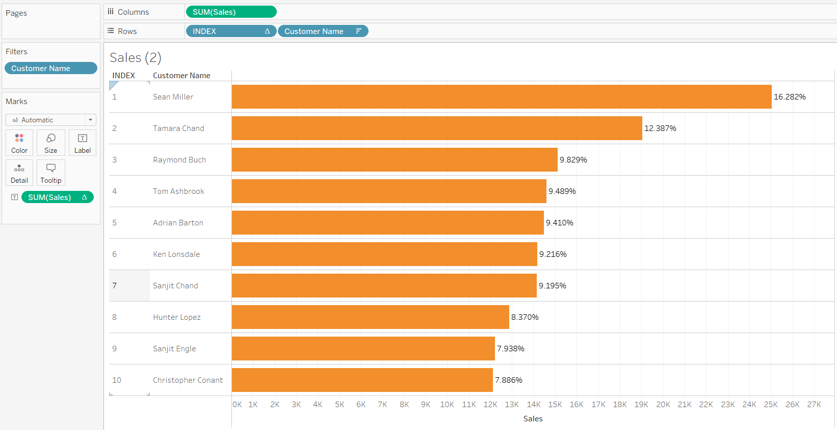What percent of total profits do the top 10 customers by Sales represent? - **Sample Superstore**

**Ans:**

1. Find the customer with the lowest overall profit. What is his/her profit ratio? - **Sample Superstore**

**Ans:** Cindy Stewart

Profit**:** -6626

Profit Ratio: -1.1645

1. Ranking States based on Sales what is the rank of state which has sales crossed $20000. - **Sample Superstore**

**Ans:**

1. What is the percent of orders which took more than 7 days on an average to deliver.

**Ans.**

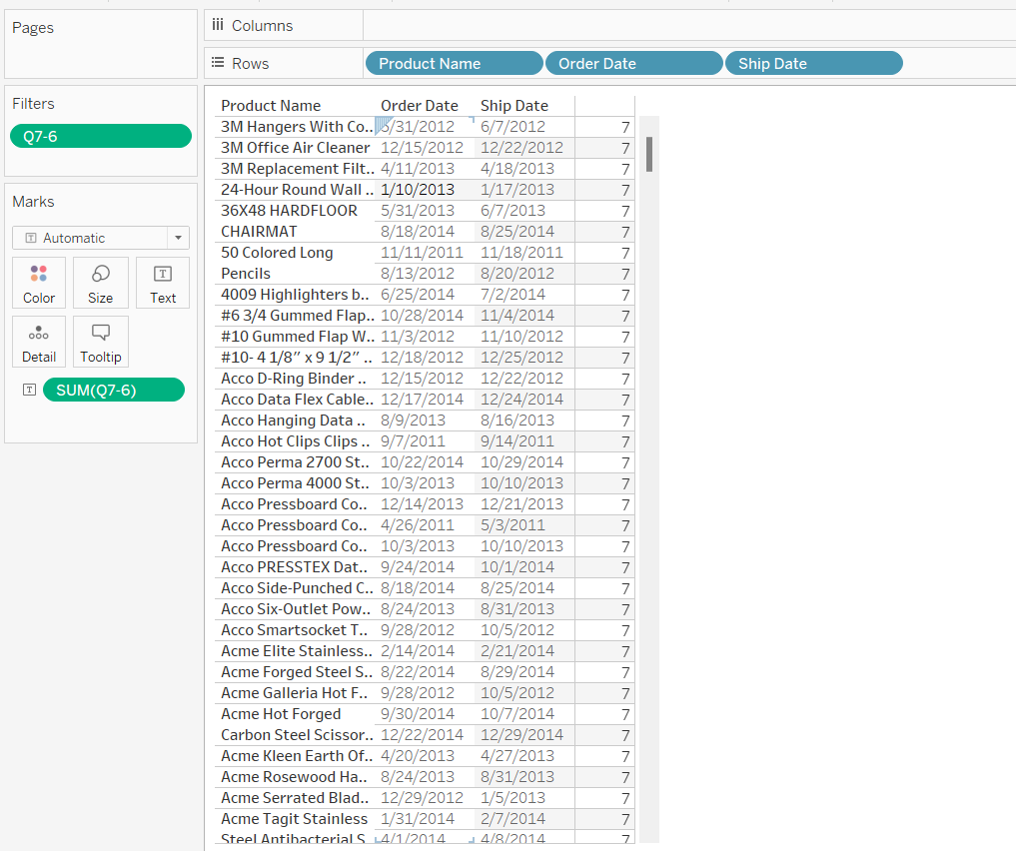

1. Use **“World Indicators”.** Without using table calculations what is the proper syntax to build a calculated field which will display overall total GDP on this view?

**Ans.** GDP [[ 658,051,981,556,719 ]]

**8. Filters:**

1. What are the different types of filters and give their working order?

**Ans.** There are basically six (6) types of filters and by order they are:

1. Extract Filter
2. Data Source Filter
3. Context Filter
4. Dimension Filter
5. Measure Filter
6. Table Calculation Filter
7. Create a list of Top 10 Products based on Profits whose sale value is more than $5000? - **Global Superstore**

**Ans:**

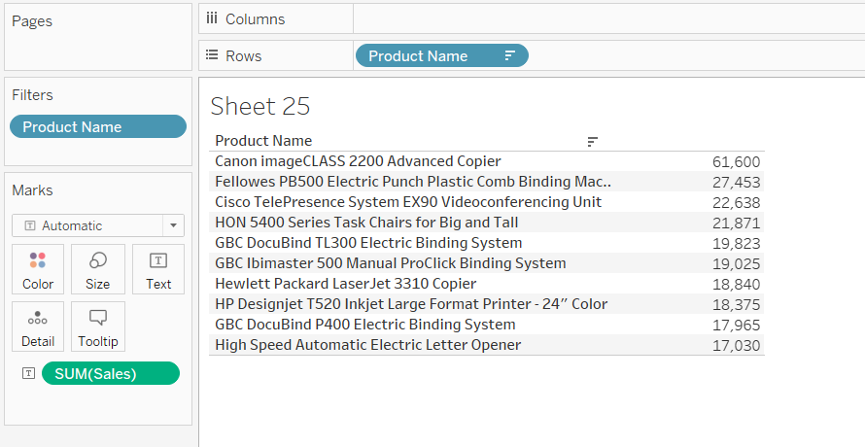

1. Create a Chart with Customer Name and Profit and check for the Sale Value for top 15 Customers? - **Global Superstore**

**Ans:**

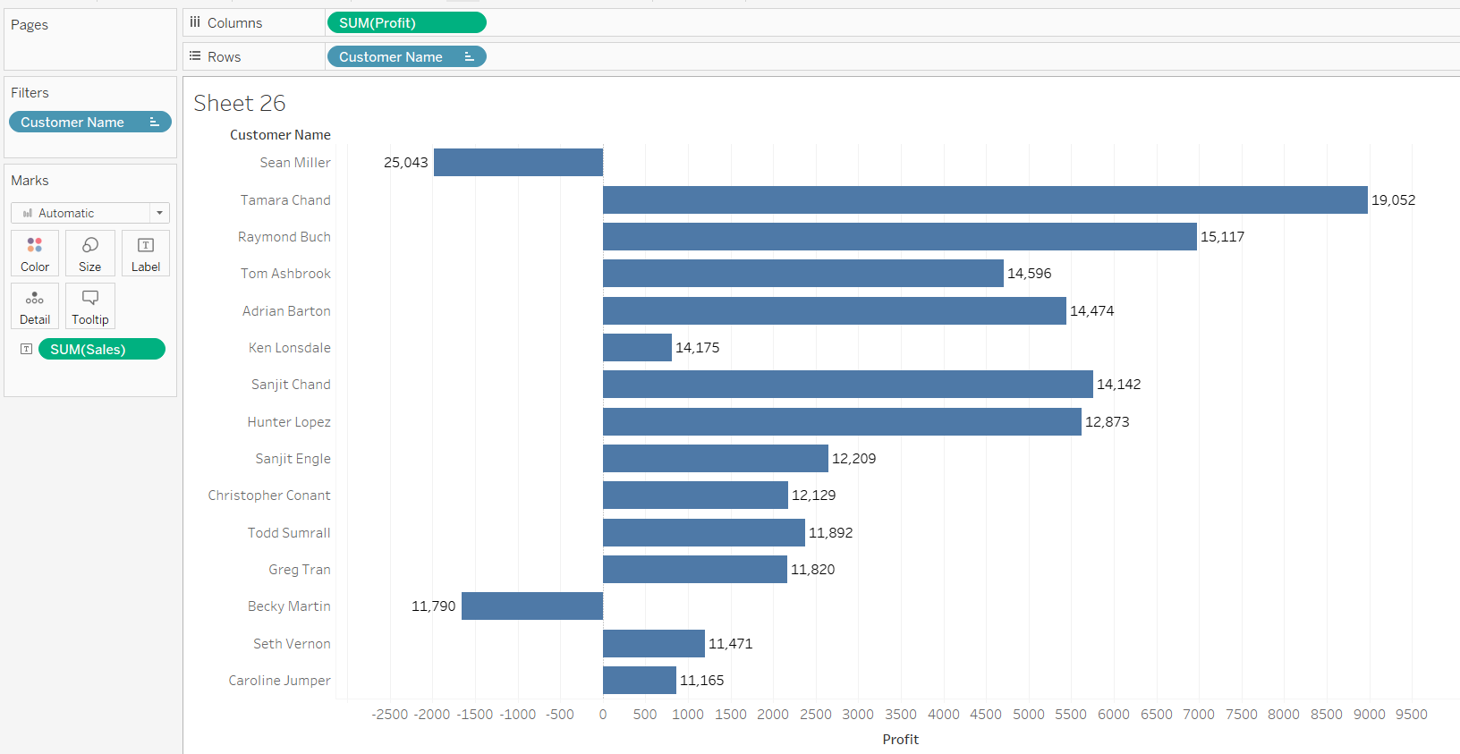

1. Apply filter to all the worksheet, filter by year 2011, then find the sum(sales) for the highest subcategory.- **Global Superstore**

**Ans:**

1. What is the name of 375th top most customer by sum of profits - **Sample Superstore**

**Ans.**

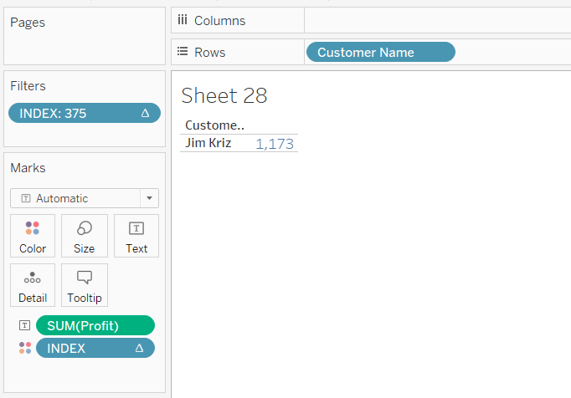

**9. Dashboards & Story:**

1. What is the different device type preview that Dashboards can use?

**Ans:** Desktop, Tablet and Phone.

1. Create a dashboard using World Indicators showing the all the Actions that can be performed in Tableau.

**Ans:**

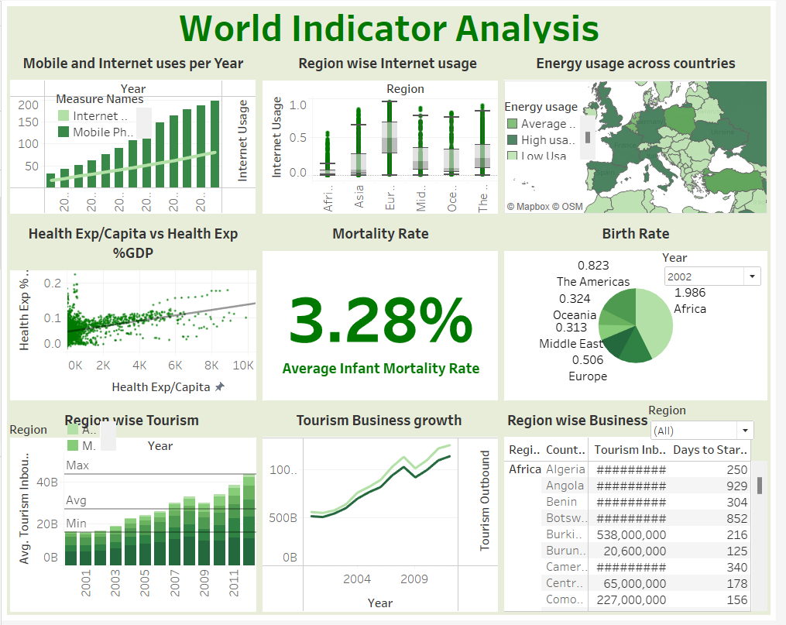

**10. Time Series:**

1. Use Order date and drill down the information for Quarter and Month level separately and show the line Chart in a Continuous Form- **Global Superstore**

**Ans:**

**11. Sets, Parameters, Groups:**

1. Parameters can be used in?

**Ans:** A parameter is a workbook variable that may substitute a constant value in a calculation, filter, or reference line. It can be an integer, date, or text.

1. What are the different ways to create a Parameter?

**Ans:**

* 1. To add a parameter, use the drop-down arrow in the top right corner of the Data window. Choose Create Parameter from the drop-down menu.
  2. While creating Filters:

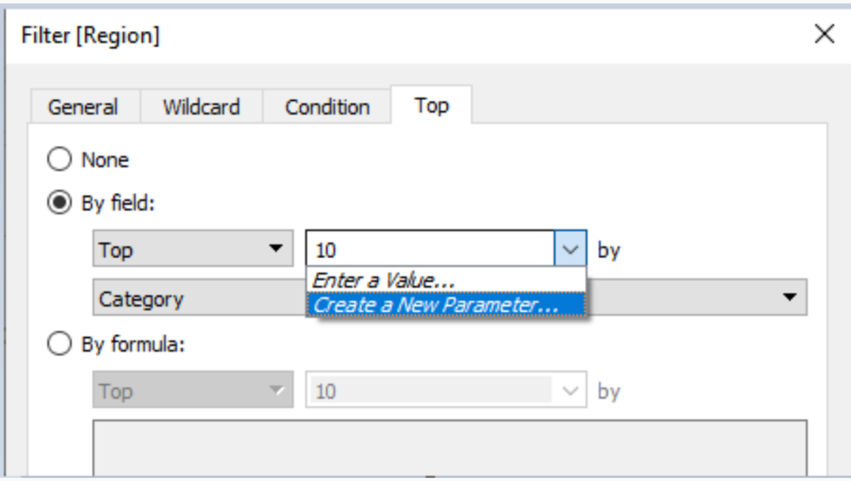

* 1. While creating sets:

* 1. While creating Bins:

* 1. Also, we can create parameter by right clicking on the dimension as below image:

**12. Forecast:**

1. You are provided with the dataset for the past 10yrs. How can you forecast the data for next 4 years, Quarter wise?

**Ans:** First of all I will convert past 10 years data into quarter wise data then after that I will forecast the data for next 4 years.

1. Use **“Sample Superstore”.** What is the Sales Forecast Estimate for the month of September 2018?

**Ans:** I have data till 2014, so I can forecast data for 2015.

Sales(Quantity):1755

**13. Pie Chart:**

1. Create a Pie Chart using regions and sum of sales, sort the pie in ascending order, increase the size in the view and label them with Count of Quantity and Sum of Profits- **Sample superstore**

**Ans:**

